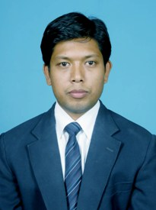

Dr. Chandrashekhar Azad
MCA (Gold Medalist), Ph.D., UGC NET
Assistant Professor

Department of Computer Applications
National Institute of Technology Jamshedpur
Email: csazad.ca@nitjsr.ac.in
Contact No. : 7909058321

Chandrashekhar Azad has received his MCA from Ranchi University, Ranchi in 2011. In his MCA degree, he has received Gold Medal for Best Master Degree in Professional Courses. He has received Ph.D. from Birla Institute of Technology, Mesra Ranchi the Department of Computer Science & Engineering in 2017. He has qualified GATE (Computer Science & Information Technology) and UGC NET (Computer Science and Applications) examinations. Currently he is working as an Assistant Professor in the Department of Computer Applications at National Institute of Technology, Jamshedpur. He has published more than 20 research papers in journals and conferences of international repute. He serves as a reviewer for various international journals and conferences. His primary area of research includes Intrusion Detection System, Meta Heuristic Algorithms, Swarm Intelligence, Pattern Recognition, Data Mining, Medical Data Mining and Machine Learning.

Topic: Machine Learning with Python

