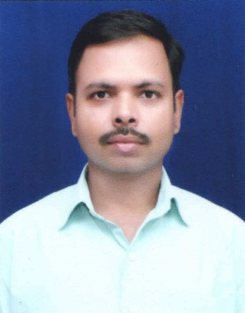
Dr. Vijay Kumar Sharma has done M.Tech. and Ph.D. in Electronics & Communication Engineering from National Institute of Technology Rourkela, India. He has published a number of research papers in international conferences and journals. He has reviewed several papers in international journal of reputes including IEEE Transactions on Cybernetics and IEEE Transactions on Circuits and Systems for Video Technology.
His research works are focused on artificial intelligence and machine learning. He has worked on online training of machine learning algorithms for video object localization for his doctoral thesis.
Currently, he is working as Data Scientist at NDS Infoserv, Mumbai. His work in this organization is to design document as well as image classifier algorithms and information extraction from unstructured data.

