


Analysis of Programmable Gain Instrumentation Amplifier
Divya Sharma¹, Shylashree N², Ramjee Prasad³ and Vijay Nath¹

¹Department of Electronics and Communication Engineering, Birla Institute of Technology, Mesra, Ranchi, India
²Department of Electronics and Communication Engineering, R.V. College of Engineering (RVCE), Bengaluru, Karnataka, India
³Director of the Center for TeleInfrastruktur (CTIF) at Aalborg University, Denmark.

ABSTRACT
This paper presents an analysis of the design of a programmable gain amplifier (PGA) based on an instrumentation amplifier. The instrumentation amplifier can be implemented in different ways, including the Single Op amp IA, 2 Op-amp INA, 3 Op-amp INA, Switched Capacitor Instrumentation amplifier (SCIA), Current Feedback Instrumentation amplifier (CFIA), Current Mirror Instrumentation amplifier (CMIA), and others. By adding switches or a multiplexer (Mux) to the amplifier, a precision programmable gain instrumentation amplifier (PG-IA) can be created. The literature suggests various approaches for enhancing the performance parameters of a PGINA, and this study aims to bring together and evaluate these approaches on a unified platform. In this research, an extensive examination of multiple instrumentational amplifier topologies has been carried out, and these topologies have been categorized based on their distinctive characteristics.
KEYWORDS
Programmable gain amplifier (PGA); Instrumentation Amplifier (INA); Common-mode-rejection-ratio (CMRR); Complementary Metal Oxide Semiconductor (CMOS); Phase Margin (PM)

- INTRODUCTION
An Instrumentation Amplifier (INA) is a category of integrated circuit (IC) which is primarily used for signal amplification. Because it increases the difference between two inputs, this amplifier belongs to the differential amplifier family [1-3]. For amplifying weak signals, an instrumentation amplifier is used due to its useful features such as high CMRR, high gain, a very high input-resistance, and quiet low offset voltage, etc [5-8]. INA is often utilized in biomedical signal acquisition systems for monitoring various health conditions [1,8,15,19,28,29], industrial test [4,11,12,30] and measurement applications [3,4,14,15,31].
The output from transducers is often of relatively low strength. The existence of the common-mode signal, for example the flicker noise of sensor, Offset-voltage, and further common-mode conflicts at the output-terminal of sensor, makes revealing and amplifications of these low-power signal challenging. As a result, the Common-mode-rejection-ratio (CMRR)of amplifier would be exceptionally high which is unable to avoid common signals interferences at sensor and amp. Interface [33,39]. A basic differential amplifier can reduce the intensity of common-mode signal while increasing the intensity of the required differential signal. However, the differential amplifier alone will be unable to reduce impact of the common-mode signal on biomedical signals or other very weak signals [42]. Therefore, an instrumentation amplifier (INA) has a very high gain and, more significantly, a very high CMRR, making it ideal for the detection of weak signals. There are Programmable Gain Amplifiers, or PGA, which have the gain options internal and can be digitally controlled.

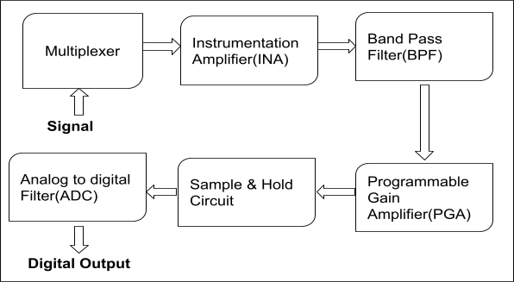
They have similar functionality but can vary vastly in characteristics. The programmable instrument amplifier (PG-INA) system block diagram is shown in Figure 1.
Fig. 1 System Block for Programmable Instrumentation Amplifier [8]
A system block diagram for Programmable instrumentation amplifier (PG-INA) is shown in Figure 1, which consists of sensor/signal, multiplexer (Mux), INA, LPF, Sample & Hold Circuit(S/H) and Analog-to-Digital converter (ADC). The sensor detects the signal which is fed to the multiplexer which sends it to INA to accomplish high open-loop gain, high CMRR and a quiet minimum noise signal. The signal is then transformed into a digital signal by passing it through LPF, S/H, and ADC. Finally output of ADC is processed in PCs or microprocessors [8]. A programmable instrumentation amplifier should have the following properties:

- High Precision gain
- High Common-mode-Rejection-Ratio
- Limited Noise
- Simple gain selection
- Low non-linearity
- Highly matched and high value of input Impedance
- Low DC offset voltage & drift

Above parameters are depending on each other and therefore, an appropriate high precision INA topology which can obtain a high gain, minimized limited noise, high CMRR, as well as less power dissipation is not easy task to develop [19],[28].

This paper is organized as follows: Section 2 contains basic insights of the Instrumentation amplifier (INA) & its operation. An analysis of basic programmable instrumentation amplifier is summarized in section 3. In section 4, a cross platform comparative performance is shown. Finally, conclusion is given in Section 5.

- EVOLUTION OF INSTRUMENTATION AMPLIFIER

Previously, there has been a misuse of the term "instrumentation amplifier" (INA), where it was commonly used to refer to the application rather than the actual device architecture. It is important to note that INAs are closely connected to operational amplifiers (op amps) as they share the same architecture. However, an INA is a specialized version of an op amp, designed and utilized for its distinctive capability of providing high differential gain. Its purpose is to amplify sensor signals at the microvolt level while effectively rejecting high-common-mode signals that can be several volts. This holds significance because certain sensors generate a comparatively low alteration in voltage or current, and it is crucial to precisely capture and measure this minimal change.

- INSTRUMENTATION AMPLIFIER

In this section, an overview of basic Instrumentation amplifier (INA). The INA is a circuit that amplifies the difference in input signal voltages while rejecting signals that are common to both inputs. INA consists of a differential amplifier along with an input buffer. The main purpose of this amplifier is to reduce excess noise generated by the circuit [32],[34-37],[40]. The 3-amp instrumentation amplifier is one of the more popular ones. The strength of this is essentially that it has high input impedance. It takes the difference amplifier and adds two buffers on each of the inputs. Those buffers have a resistive network around it that allows it to gain up the differential voltage. The benefits of a 3-amp instrumentation amplifier are the high input impedance caused by these buffers, as well as the ability to gain it up and the limitation is the restricted Common Mode Voltage range [20-24],[41].
The Traditional INA based on 3 Operational Amplifier is shown in figure 2[3]. Input polarities with VIN- & VIN+ are present at input stage along with differential amplifier (A3) present at output stage. Inputs of INA can be described as follows:
$$V_{CM}=\frac{V_{IN-}+V_{IN+}}{2} \& V_{D}=V_{IN+}-V_{IN-} (1)$$

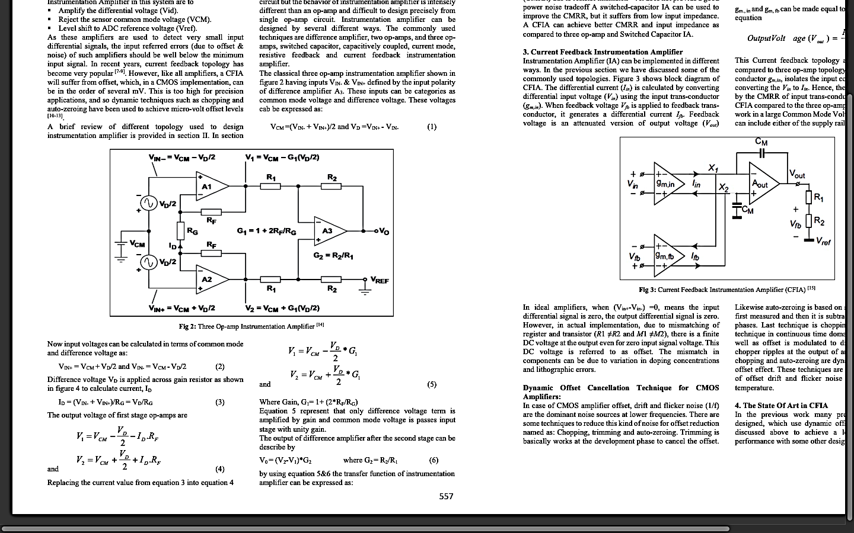

Fig. 2 A Traditional 3 Op-Amp Instrumentation Amplifier (INA) [3]

In term of difference voltage & Common mode, the input voltage is calculated as:
$$V_{IN+}=V_{CM}+\frac{V_{D}}{2} \& V_{IN-}=V_{CM}-V_{D}/2 (2)$$

To calculate Current ID, Difference voltage is applied across the gain resistor.
$$I_{D }=\left(V_{IN-}+V_{IN+}\right){/R}_{G}=\frac{V_{D}}{R_{G}} (3)$$
$$V_{1}=V_{CM}-\frac{V_{D}}{2}-I_{D}.R_{F} \& V_{2}=V_{CM}+\frac{V_{D}}{2}+I_{D}.R_{F} (4)$$

Substitute ID value of equation 4 from equation 3
$$V_{1}=V_{CM}-\frac{V_{D}}{2}*G_{1} \& V_{2}=V_{CM}+\frac{V_{D}}{2}*G_{1} (5)$$

Where Gain, $G_{1}=1+(2*\frac{R_{F}}{R_{G}})$

The $V_{D}$ is intensified by gain and the common-mode voltage has been passed through the input stage alongside unity gain. The output of the difference amplifier after the second stage is represented by,

$$V_{0}=\left(V_{2}-V_{1}\right)*G_{2} where G_{2}=\frac{R_{2}}{R_{1}} (6)$$

The transfer function of INA can be calculated using equation 5 and 6,
$$\frac{V_{0}}{V_{D}} = G_{1}*G_{2}=G_{TOTAL} (7)$$

INA has a limited CMRR value due to resistor mismatching [25]. A unity-gain difference amplifier is used in the output stage of a traditional INA, which may limit the input common range as a result. [3],[26]. A switched-capacitor INA may be utilized to increase CMRR, although, it has a low input impedance [38].

- CIRCUIT OF A BASIC PROGRAMMABLE AMPLIFIER(PGA)

The PG-IA's fundamental circuit is shown in figure. 3 [10]. For input signal $E_{1}$, Operational amplifiers $A_{1}$& $A_{2}$ form an inverter. Summing junction is Node A, input signal $E_{2}$ and the Feedback. The circuit steady state equations are given as follows:

$$U_{2}=e_{1}=E_{1} (8)$$

$$U_{3}=e_{4}=E_{2} (9)$$

$$\sum{I_{A}=0; }\frac{U_{1}}{R_{3}}+\frac{U_{3}}{R_{4}}+\frac{U_{4}}{R_{0}}.\frac{D}{2^{N}-1}=0 (10)$$

$$\sum{I_{B}=0; }\frac{U_{1}}{R_{2}}+\frac{U_{2}}{R_{1}}=0 (11)$$

Where,

$$G : A Gain controlling DAC ,$$

$R_{0} : an i/p resistance of the DAC-G reference input (U_{REF})$

$D : A$ DAC-G loading (0 < D ≤ $2^{N}-1$),

$$N : A DAC-G resolution (bits).$$

After mathematically analysis of (8)-(11) equations give Op-Amp output Voltage A4 and Output Voltage of the Instrumentation amplifier after inspection of the circuit is

$$U_{0}=U_{4}=\frac{2^{N}-1}{D}.R_{0}.\left(\frac{R_{2}}{R_{1}}.\frac{E_{1}}{R_{3}} \frac{E_{2}}{R_{4}}\right) (12)$$

Above equation is resolved into input signal amplified Sum & difference components.
$$U_{0}=\frac{2^{N}-1}{D}.{\frac{R_{0}}{R_{4}} \left[\frac{1}{2}\left(1+\frac{R_{2}R_{4}}{R_{1}R_{3}}\right)\left(E_{1}E_{2}\right)+\frac{1}{2}\left(\frac{R_{2}R_{4}}{R_{1}R_{3}} 1\right)\left(E_{1}+E_{2}\right)\right]}_{.} (13)$$
An ideal instrumentation amplifier is created by balanced condition $R_{1}.R_{3}=R_{2}{.R}_{4}$of the resistor “bridge $R_{1 }{via R}_{4}:$
$U_{0}=\frac{2^{N}-1}{D}. \frac{R_{0}}{R_{4}}. \left(E_{1} E_{2}\right) (14)$ 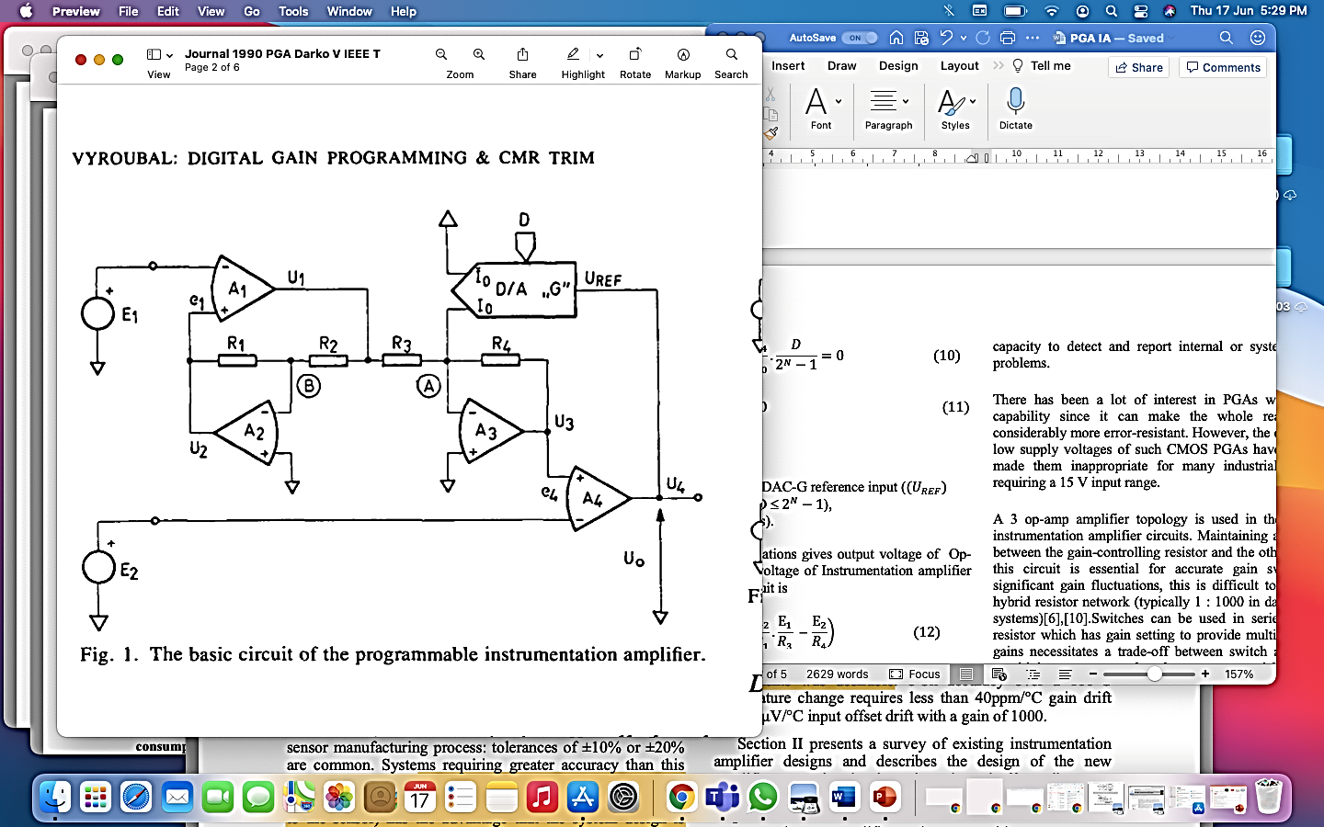Fig. 3 Basic circuit of PGIA [10]
Figure 3 is basis for precision PG-IA, but it has demerit of the gain proportionality to the ratio of the reference resistance$R_{0} to R_{4}$ of DAC. As a result, only if the resistor “bridge” with a DAC R-2R ladder, the simple circuit in figure. 3 is an unsuitable for the real-world application (example, Temperature tracking and adjustment of the resistance ratio are also available) [10].
In industrial signal-acquisition applications, there are two types of PGAs and IAs currently known. A first category uses laser pruning to produce a good noise & D.C accuracy in a High Voltage (HV)Bipolar technology. These can handle up to 15V in common mode and differential-input voltage, which is generally employed in the industrial purposes. Because of a usage of bipolar technology and trimming, such ICs have lack of diagnostics, restricted programmability and an auxiliary capability, even they are rather expensive. Several of these IC’s have restricted CMRR which is roughly of 80dB at low volume levels [12].
Analog CMOS technology is used to build a second category of PGAs. This eliminates the requirement for trimming by allowing the utilization of dynamic Offset Cancellation methods which increase the D.C accuracy [17], [25-27]. Furthermore, CMOS technology enables the inclusion of a digital interface, as well as additional functions for example Sensor excitation as well as sensor linearization and capacity to reveal and report inbuilt / system level fault problems.
There has been a lot of interest in PGAs with this extra capability since it can make the whole readout system considerably more error resistant. However, the comparatively low-supply voltages, CMOS PGA’s have traditionally been inappropriate for several applications of industry requiring a 15 V input range.
A 3 op-amp amplifier topology is used in most instrumentation amplifier circuits. Maintaining a precise ratio between the resistor with gain controlling and another resistor within that circuit which is essential for accurate gain switching. For significant gain fluctuations, in a hybrid resistor network is difficult to obtain (typically 1: 1000 in data acquisition systems) [6],[10]. Switches can be used in series along with resistor which has gain setting to provide multiple selectable gains necessitates trade off amongst switching area & gain sensitivity of a power supply voltage, process variables and signals level [4].
  - Programmable Gain:
Any system's dynamic range may be increased by using programmable gain. The practical range of a fixed gain instrumentation amplifier would be around 60dB [9,10,16]. To permit signal levels amplification in broad range then both high resolution (approx. about 0.4%) as well as wide-gain range (of about minimum 100 -1000) is required for programmable gain [4]. In data acquisition space, PG-IA are most crucial component which enables better signal to noise ratio performance as well as varied sensor sensitivities. Compact IC designing approaches may also be used to decrease parasitic and offer great matching, leading in better ac performance. Due to these benefits, if an integrated PGIA matches the design criteria, it is always suggested to employ it [7].
- DIFFERENT TYPE OF TECHNIQUE USED BY PROGRAMMABLE INSTRUMENTATION AMPLIFIER(PG-INA)

Many researchers have utilised various technique to employ instrumentation amplifier based on programmable gain [9-16]. In this article, V to I and I to V converters [12], Current Division Network technique [13] and Supply Current sensing technique [14] is briefly discussed.
  - V to I & I to V Converters
In this paper [12], a high voltage programmable gain precision instrumentation amplifier with high CMRR approx. more than 120dB at all gain settings as well as sub-20µV offset has been proposed for the first-time signals acquisition in the industrial sector. Restricted programmability, a scarcity of diagnostics & auxiliary features, & a comparatively expensive because of the utilization of bipolar technology and pruning are all disadvantages of conventional ICs. In this work, total of four op amps and four OTAs are used, which need dynamic offset correction. The output amplifier stage converts an input voltage to a current, which is then reflected by precise current mirrors before being converted back to a voltage. To remove chopping glitches, notch filter for chopper stabilisation is used in all the opamp in the PGA, resulting in low offset & drift as well as no 1/f noise. Low offset is ensured by the chopped high gain path with $g_{min}$ & $g_{m2}$, while broad bandwidth is ensured by a parallel feed-forward stage gmff. To decrease the requirement for device calibration and to maintain precision over time and temperature, offset drift, gain drift, and non-linearity must be reduced, while noise must be removed.

Furthermore, this PGA architecture increment input of common mode range & offers level conversion amongst the low-voltage (LV) output supply and high-voltage (HV) input supply domain. It has achieved an unclipped CMRR ratio over 120dB at all gain settings. This network provides numerous system-level diagnostic features may also be used as a two-channel multiplexer. The IA chip is executed with a 36 V extension in a 0.35m CMOS technology.

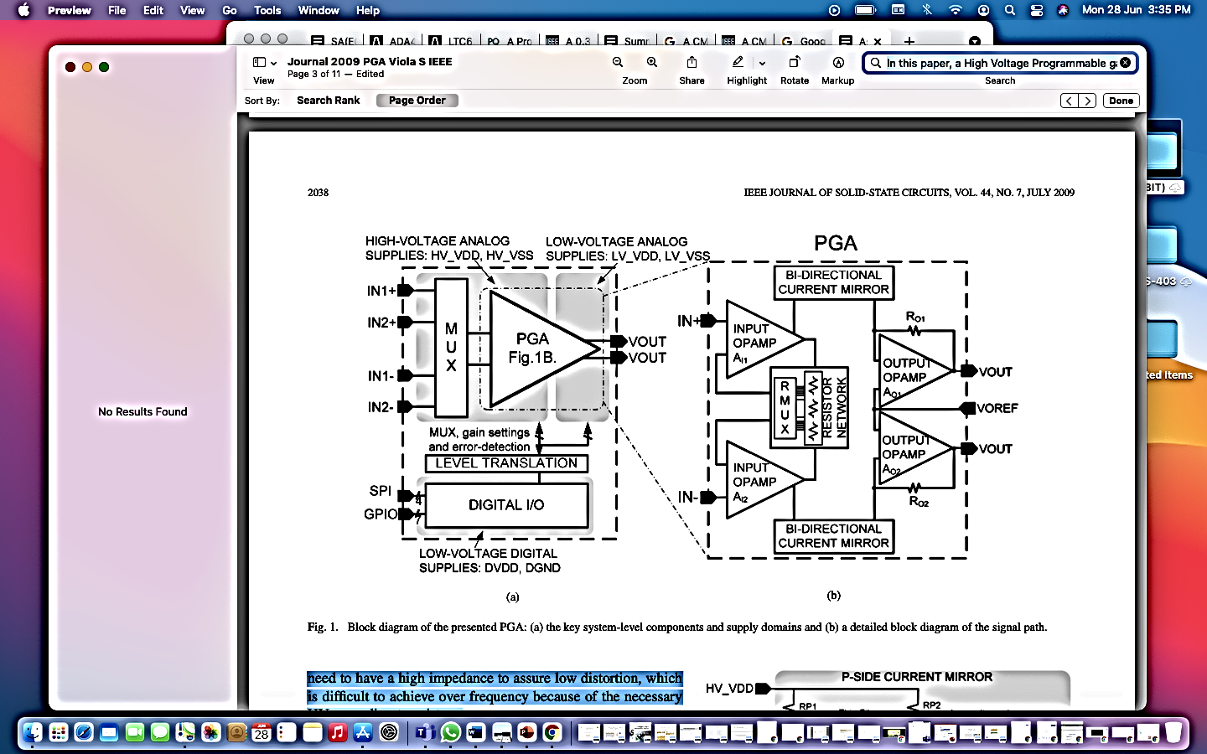Fig. 4 Block diagram of Programmable gain INA with signal path [12].
  - Current division Network (CDN)
In this proposed work [13], Digitally Programmable Op-amp Transconductance Amplifier (DPOTA) is connected in series with the digital controlled gyrator in a proposed IA. For a 4-bit code word, the DPOTA's digital control circuit uses a current-division-network (CDN). This PG-INA is proposed for Biomedical application such as EEG signal detector. As shown in Fig. 5, this OTA is made up of 4 transistors cell (M1 to M4), Voltage biased circuit & Current -sensing-circuits (M5 to M10), 2 levels shifter (M11 to M20) ,2 Current Subtractors (M21 to M28), & Common mode feedback circuits (CMFC)(Mcm1 to Mcm10. It produces very little noise and consumes very little electricity. The digital control is configured to a 4-bit code word via CDN. A designed cascaded INA operated with the smallest power source, absolute least Power dissipation (PD), highest gain, & highest CMRR. The designed cascaded IA with the smallest power supply, lowest power dissipation, greatest gain, and highest CMRR was created.

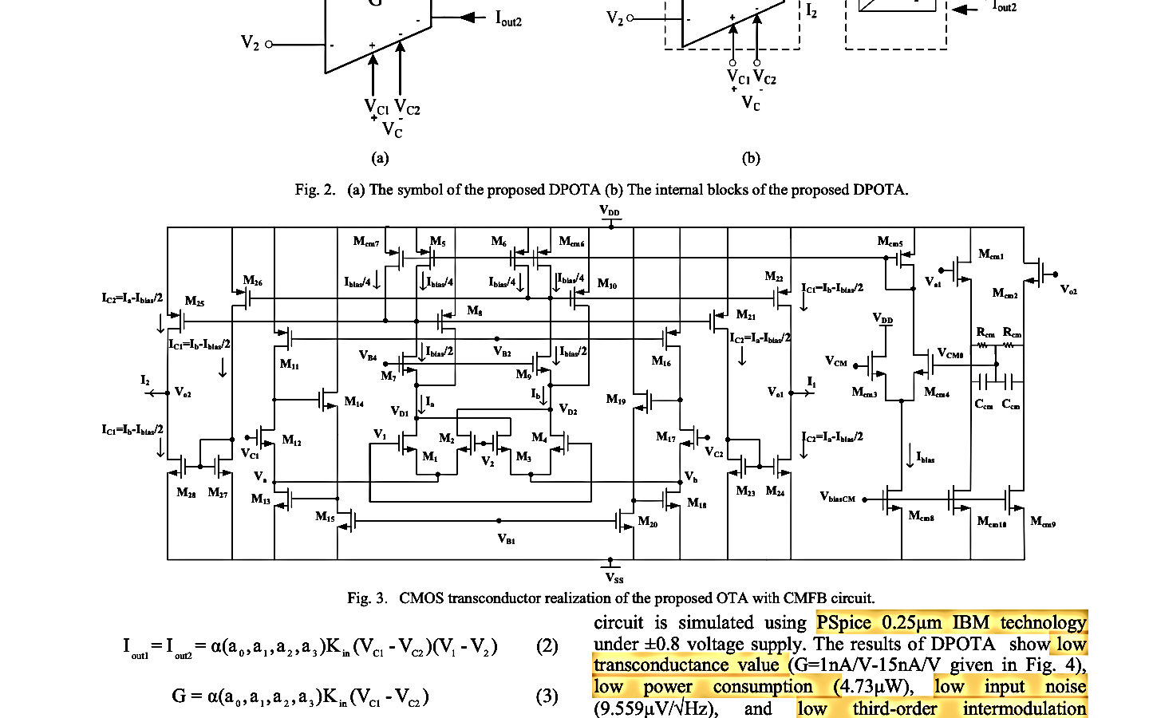

Fig. 5 The designed OTA circuit with CMFB is realised in CMOS transconductor [13].
  - Supply Current Sensing Approach (SCS)
In this proposed work [14], A supply current sensing approach is used to design the low-voltage (LV), low-power (LP) Instrumentation amplifier (INA). 3 Voltage Buffers (VBs), two resistors, and current mirror are comprised in this proposed circuit as shown in Figure 6. Instead of using an Op-amp in a unity-gain configuration but a Voltage Buffer (VB) is utilised in the proposed circuit, and it is demonstrated that a high CMRR can be reached with just a better match between the input-buffer gain. Advantage of INA: it’s CMRR is unaffected by mismatching of Resistor, eliminating the need for costly resistor laser trimming. INA schematic based on supply Current Sensing (SCS) Technique is shown in Figure 6. 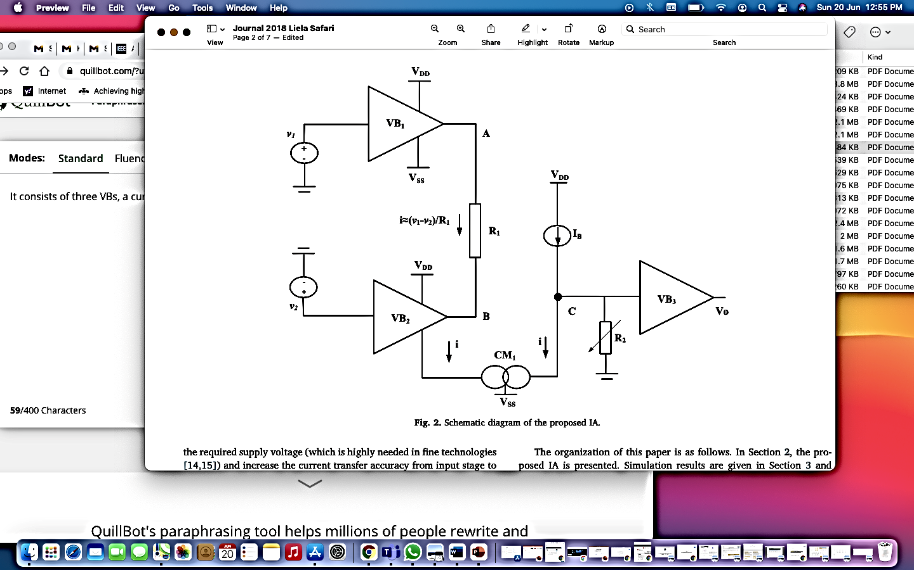
Fig. 6 INA schematic based on supply Current Sensing (SCS) Technique [14].

The performance comparisons between the various INA topologies are shown in Table 1.
Table. 1 Cross platform comparative performance
Parameter | [12] | [13] | [14] | [FUTURE WORK]
Technology | 0.35μm | 0.25μm | 0.18μm | 180nm
Supply voltage (V) | 36 | ± 0.8 | 1.8 | 3.3
Gain(dB) | -18/42 | 13.81/60.15 | 0/18 | 1 to 1000
CMRR (dB) | 120 | 113.4 | 71 | >90dB
Gain Band width (Hz) | 2M | 270k | 83M | 1MHz
Input Referred Noise(V/Hz) | 3.8μ | 2.62μ | -- | Low
Power Dissipation(W) | -- | 27.4μ | 0.77m | Low

- CONCLUSION
A comparative study of programmable instrumentation amplifier using different technology is presented in this article, in which V-to-I & I-to-V converters, current division network (CDN) and supply current sensing approach (SCS) are used. The study shows that supply current sensing approach gives high gain bandwidth compared to other technology. In this technology CMRR is unaffected by resistor mismatch as well as expensive resistor laser trimming need is eliminated.

Future scope: using SCL 180nm CMOS technology, create a high-precision INA with adjustable gain for aerospace applications. A high gain that can be programmed in software. A CMOS multiplexer and an appropriate network of resistors can be used to build INA. To accomplish the digitally adjustable gain, internal precision resistor arrays are employed. On-chip trimming of these resistor arrays can increase gain, CMRR, and offsets, resulting in higher overall dc efficiency.

REFERENCES

- Goel A. & Singh G. (2013). A Novel Low Noise High Gain CMOS Instrumentation Amplifier for Biomedical Applications. International Journal of Electrical and Computer Engineering, 3(4), 516-52. http://dx.doi.org/10.11591/ijece.v3i4.3170
- Razzavi B. (2012) Design of Analog CMOS Integrated Circuit. Tata McGraw Hill Education.
- Thomas Kugelstadt. (2005). Getting the most out of your instrumentation amplifier design, Analog Applications Journal. Texas Instruments Incorporated, Texas, USA, 25-30. https://www.ti.com/lit/pdf/slyt226
- Tang, A. T. K. (2005). Enhanced programmable instrumentation amplifier, SENSORS, IEEE, Irvine, CA, USA, 1-4. https://doi.org//10.1109/ICSENS.2005.1597859
- Analog Devices. (2006). Programmable Gain Instrumentation amplifier AD625, One Technology Way, C00780c–0–6/00 (rev. D), 1-15. https://www.analog.com/media/en/technical-documentation/data-sheets/ad625.pdf
- Kultgen M. (2005). Simple, Precise Instrumentation Amplifier Features Digitally Programmable Gains from 1 to 4096. Analog Devices, Linear Technology Magazine, 16-19. https://www.analog.com/en/technical-articles/simple-precise-instrumentation-amplifier-features-digitally-programmable-gains.html
- Fortunado K. (2018). Programmable Gain Instrumentation Amplifier: Find the best amplifier for you, Analog Dialogue, 52, 1-6.https://www.analog.com/en/analog-dialogue/articles/programmable-gain-instrumentation-amplifiers-finding-one-that-works-for-you.html
- Mourya S., Naik P. & Sharma P. (2013). Designing of Current Mode Instrumentation Amplifier for Bio-Signal Using 180nm CMOS Technology. International Journal of Engineering Research & Technology (IJERT), 2(4), 2529-2534. https://doi.org/10.17577/IJERTV2IS4947
- Roy S. C. D. (1984). Digitally Programmable Gain Amplifiers. IEEE Transactions on Instrumentation and Measurement, 33 (4), 329-332. https://doi.org/10.1109/TIM.1984.4315234
- Vyroubal D. (1990). Instrumentation amplifier with digital gain programming and common-mode rejection trim. IEEE Transactions on Instrumentation and Measurement, 39(4), 588-593 https://doi.org/10.1109/19.57238
- Di Ciano M., Tangorra R. & Marzocca C. (1996). Designing a low cost, low noise programmable gain instrumentation amplifier. Proceedings of 8th Mediterranean Electrotechnical Conference on Industrial Applications in Power Systems, Computer Science and Telecommunications (MELECON 96), 3, 1263-1266. https://doi.org.10.1109/MELCON.1996.551175
- Schaffer V., Snoeij M. F., Ivanov M. V. & Trifonov D. T. (2009). A 36 V Programmable Instrumentation Amplifier with Sub-20 μ\muV Offset and a CMRR in Excess of 120 dB at All Gain Settings. IEEE Journal of Solid-State Circuits, 44, 2036-2046. https://doi.org/10.1109/JSSC.2009.2021921
- Mahmoud S. A. and Alhammadi A. A. (2015). A CMOS digitally programmable OTA based instrumentation amplifier for EEG detection system. 2015 IEEE International Conference on Electronics, Circuits, and Systems (ICECS), 543-546. https://doi.org/10.1109/ICECS.2015.7440374
- Adimulam M. K., Movva K. K., Kolluru K. and Srinivas M. B. . (2017). A 0.32 µW, 76.8 dB SNDR Programmable Gain Instrumentation Amplifier for Bio-Potential Signal Processing Applications. 2017 IEEE Computer Society Annual Symposium on VLSI (ISVLSI), 655-660.

- Schoeneberg U., Hosticka B. J. & Schnatz F. V. (1991). A CMOS readout amplifier for instrumentation applications. IEEE Journal of Solid-State Circuits, 26(7) 1077-1080. https://doi.org//10.1109/4.92029
- Menolfi C. & Huang Qiuting. (1999). A fully integrated, untrimmed CMOS instrumentation amplifier with submicrovolt offset. IEEE Journal of Solid-State Circuits, 34(3), 415-420. https://doi.org/10.1109/4.748194
- Eldeeb M. A., Ghallab Y. H., Ismail Y. & El ghitani H. (2016). Design of low power CMOS subthreshold current mode instrumentation amplifier based on CCII. 2016 IEEE 59th International Midwest Symposium on Circuits and Systems (MWSCAS), Abu Dhabi, 1-4. https://doi.or/10.1109/MWSCAS.2016.7870137
- Ren M., Zhang C.X. & Sun D. S. (2012). Design of CMOS Instrumentation Amplifier. Procedia Engineering. 29, 4035-4039(Vol. 29). https://doi.org//10.1016/j.proeng.2012.01.615
- Gupta G. & Tripathy M. R. (2014). CMOS Instrumentation amplifier design with 180nm technology. 2014 International Conference on Circuits, Power and Computing Technologies [ICCPCT-2014], Nagercoil, India, 1114-1116. https://doi.org//10.1109/ICCPCT.2014.7055007
- Bardyn J., Kaiser A. & Stefanelli B. (1990). A Very Low-Noise Instrumentation Amplifier using a Standard CMOS Process for Digital Chips. ESSCIRC '90: Sixteenth European Solid-State Circuits Conference, Grenoble, France, 29-32.
- Nielsen J.H., & Bruun E. (2004). A CMOS Low-Noise Instrumentation Amplifier Using Chopper Modulation. Analog Integr Circ Sig Process, 42, 65–76. https://doi.org//10.1007/s10470-004-6849-8
- Saurabh S., Saifi M., Karatangi S.V., & Rai A. (2020). Design of CMOS Instrumentation Amplifier Using Three-Stage Operational Amplifier for Low Power Signal Processing. In: G.Mathur, H.Sharma, M. Bundele, N. Dey, M. Paprzycki (eds) International Conference on Artificial Intelligence: Advances and Applications 2019. Algorithms for Intelligent Systems. Springer, Singapore. https://doi.org//10.1007/978-981-15-1059-5_9
- Eldeeb M. A., Ghallab Y. H., Ismail Y. & El Ghitani H. (2018). An 89 nW instrumentation amplifier for IoT in 65 nm CMOS technology. 2018 35th National Radio Science Conference (NRSC), Cairo, Egypt, 345-351, https://doi.org//10.1109/NRSC.2018.8354394
- Wu R., Huijsing J.H., & Makinwa K.A.A. (2011). A Current Feedback Instrumentation Amplifier with a Gain Error Reduction Loop and 0.06 % Untrimmed Gain Error. IEEE Journal Solid State Circuits, 46(12), 2794-2806. https://doi.org/10.1109/JSSC.2011.2162923
- Eldeeb M. A., Ghallab Y. H., Ismail Y. & El ghitani H. (2016). Design of low power CMOS subthreshold current mode instrumentation amplifier based on CCII. 2016 IEEE 59th International Midwest Symposium on Circuits and Systems (MWSCAS), Abu Dhabi, 1-4. https://doi.org//10.1109/MWSCAS.2016.7870137
- Goel V., Surshetty S. K., Prasad D. & Nath V. (2019),. Design of an Area Efficient and High-gain CMOS Instrumentation Amplifier for VLSI Applications. 2019 Innovations in Power and Advanced Computing Technologies (i-PACT), Vellore, India, 1-6. https://doi.org//10.1109/i-PACT44901.2019.8960230
- Worapishet A., Demosthenous A. & Liu X. (2011). A CMOS Instrumentation Amplifier With 90-dB CMRR at 2-MHz Using Capacitive Neutralization: Analysis, Design Considerations, and Implementation. IEEE Transactions on Circuits and Systems I: Regular Papers, 58(4), 699-710 https://doi.org//10.1109/TCSI.2010.2078850
- Venkata Krishna O. et. al. (2015). Design and Implementation of Instrumentation Amplifier for EEG in 180nm CMOS technology. CVR Journal of Science and Technology, 8, 57-64. http://dx.doi.org/10.32377/cvrjst0811
- Sanjay, R., Venkataramani, B., Kumaravel, S. et al. (2021). A Low-Noise Area-Efficient Current Feedback Instrumentation Amplifier. Circuits Syst Signal Process, 40, 1496–1510. https://doi.org/10.1007/s00034-020-01527-2.
- Minch B. A. (2017). A CMOS differential-difference amplifier with class-AB input stages featuring wide differential-mode input range. 2017 IEEE International Symposium on Circuits and Systems (ISCAS), 1-4. https://doi.org//10.1109/ISCAS.2017.8050488
- Riem R., Raman J., Borgmans J. & Rombouts P. (2021). A Low-Noise Instrumentation Amplifier with Built-in Anti-Aliasing for Hall Sensors, in IEEE Sensors Journal, 21(17), 18932-18944,. https://doi.org//10.1109/JSEN.2021.3090251
- F. Neves, J. P. Oliveira & H. Oliveira (2021), A sub-1V CMOS Instrumentation Amplifier for an AFE Interfacing with Sensors, 2021 International Young Engineers Forum (YEF-ECE), 1-6. https://doi.org//10.1109/YEF-ECE52297.2021.9505076
- Fan Q., Huijsing J. H. & Makinwa K. A. A. (2012). A 21 nV/√ Hz chopper stabilized multi-path current-feedback instrumentation amplifier with 2 µV offset. IEEE J. Solid-State Circuits, 47(2), 464-475. https://doi.org/10.1109/JSSC.2011.2175269
- Lin T. N., Wang B., Belhaouari S. B. & Bermak A. (2020). A Chopper Instrumentation Amplifier with Amplifier Slicing Technique for Offset Reduction. 2020 IEEE International Symposium on Circuits and Systems (ISCAS), 1-5. https://doi.org//10.1109/ISCAS45731.2020.9180507
- Peddiraju B., Jatoth R. K. & Duggirala N. (2014). Performance Comparison of Instrumentation Amplifiers – A Beginner's View, International Conference on Data Data Acquisition, Transfer, Processing & Management [ICDATPM-2014], 138-143. https://doi.org//10.13140/2.1.4709.6966
- Sankaran K. S. & Purushothaman K. E. (2017). Adaptive Enhancement of Low Noise Amplifier Using Cadence Virtuoso Tool. 2017 Second International Conference on Recent Trends and Challenges in Computational Models (ICRTCCM), 330-334, https://doi.org//10.1109/ICRTCCM.2017.37
- Ivanov E. V. (2012). Switched-capacitor level-shifting technique with sampling noise reduction for rail-to-rail input range instrumentation amplifiers, IEEE Trans. on Cir. and Sys.-I, 59(12), 2867-2880. http://dx.doi.org/10.1109/TCSI.2012.2206455
- Serra H., Bastos I., de Melo J. L. A., Oliveira J. P., Paulino N., Nefzaoui E., & Bourouina T. (2019). A 0.9-V Analog-to-Digital Acquisition Channel for an IoT Water Management Sensor Node. IEEE Transactions on Circuits and Systems, 66(10), 1678-1682. https://doi.org/10.1109/TCSII.2019.2933276
- Yaul F. M. & Chandrakasan A. P. (2017). A noise-efficient 36 nV/√ Hz chopper amplifier using an inverter-based 0.2-V supply input stage. IEEE J. Solid-State Circuits, 52(11), 3032-3042. https://doi.org/10.1109/JSSC.2017.2746778
- Lin T. N., Wang B. & Bermak A. (2018). Review and Analysis of Instrumentation Amplifier for IoT Applications, 2018 IEEE 61st International Midwest Symposium on Circuits and Systems (MWSCAS), 2018, 258-261, https://doi.org/10.1109/MWSCAS.2018.8623882
- Yazicioglu R. F., Merken P., Puers R., & Hoof C. V. (2007). A 60 W 60 nV Hz readout front-end for portable biopotential acquisition systems. IEEE J. Solid-State Circuits, 42(5), 1100–1110. https://doi.org//10.1109/JSSC.2007.894804
- Kaushik R., & Kaur J. (2021). Design of folded cascode op amp and its application – bandgap reference circuit. Circuit World., 101, 182-191. https://doi.org/10.1108/CW-10-2019-0137
- Sharma D., Rai A., Debbarma S., Prakash O., Ojha M K & Nath V. (2023). Design and Optimization of 4-Bit Array Multiplier with Adiabatic Logic Using 65 nm CMOS Technologies, IETE Journal of Research, 1-14. https://doi.org/10.1080/03772063.2023.2204857


Divya Sharma received her BTech degree from A.K.T.U, Uttar Pradesh, India in 2014 and MTech degree in microelectronics systems and embedded technology from Jaypee Institute of Information Technology, Noida, India in 2016. She is currently pursuing PhD at the Department of Electronics and Communication Engineering, Birla Institute of Technology Mesra, Ranchi, Jharkhand, India. Her areas of interest are low-power VLSI design, digital VLSI design, cryptography and network security.
E-mail: phdec10053.20@bitmesra.ac.in


Shylashree N received her BE degree in electronics & communication engineering from BMS College of Engineering Bangalore, India in 2006 and M.Tech degree from JSSATE Bangalore, India in 2008 and PhD degree in faculty of electrical and electronics engineering sciences from PESCE Mandya(VTU) India in 2017. Her areas of interest are network analysis, analysis and design of digital circuits, digital VLSI design, analog & mixed mode VLSI design, low power VLSI design, cryptography & network security, statistics and linear algebra and control engineering.
E-mail: shylashreen@rvce.edu.in


Ramjee Prasad is currently the Director of the Center for TeleInfrastruktur (CTIF) at Aalborg University, Denmark and Professor, Wireless Information Multimedia Communication Chair. Ramjee Prasad is the Founding Chairman of the Global ICT Standardization Forum for India (GISFI: www.gisfi.org) established in 2009. GISFI has the purpose of increasing of the collaboration between European, Indian, Japanese, North American and other worldwide standardization activities in Information and Communication Technology (ICT) and related application areas. He was the Founding Chairman of the HERMES Partnership – a network of leading independent European research centers established in 1997, of which he is now the Honorary Chair.
E-mail: ramjee@btech.au.dk


Vijay Nath received his BSc degree in physics from DDU University Gorakhpur, India in 1998 and PG Diploma in computer networking from MMM University of Technology Gorakhpur, India in 1999 and MSc degree in electronics from DDU University Gorakhpur, India in 2001, and PhD degree in electronics from Dr. Ram Manohar Lohiya Avadh University Ayodhya (UP) and in association with CEERI Pilani (Raj), India in 2008. His areas of interest are ultra-low-power temperature sensors for missile applications, microelectronics engineering, mixed-signal design, application-specific integrated circuit design, embedded system design, cardiac pacemaker, internet of things, artificial intelligence & machine learning, and computational intelligence.
Corresponding author E-mail: Vijaynath@bitmesra.ac.in

